Ideation Phase
Define the Problem Statements

Date | 09 July 2026
Team ID
Project Name | Customer Registry
Maximum Marks | 2 Marks

Customer Problem Statement Template:
Create a problem statement to understand your customer's point of view. The Customer Problem Statement template helps you focus on what matters to create experiences people will love.
A well-articulated customer problem statement allows you and your team to find the ideal solution for the challenges your customers face. Throughout the process, you’ll also be able to empathize with your customers, which helps you better understand how they perceive your product or service.

Reference: https://miro.com/templates/customer-problem-statement/
Example:
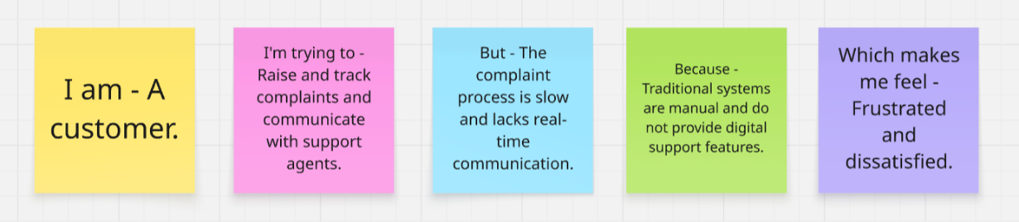

Problem Statement (PS) | I am (Customer) | I’m trying to | But | Because | Which makes me feel
PS-1 | A customer using a service organization | Raise and track complaints and communicate with support agents | The complaint process is slow and lacks real-time communication | Traditional systems are manual and do not provide digital support features | Frustrated and dissatisfied
PS-2 | An administrator managing customer support operations | Assign complaints and monitor agents efficiently | Existing systems lack centralized management and analytics | The available tools are fragmented and inflexible | Overwhelmed and inefficient

